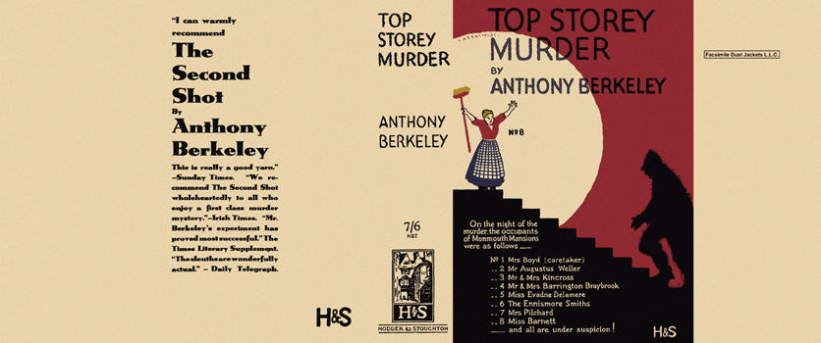

Top Storey Murder
Berkeley, Anthony
Hodder & Stoughton (UK) (1931) first printing.

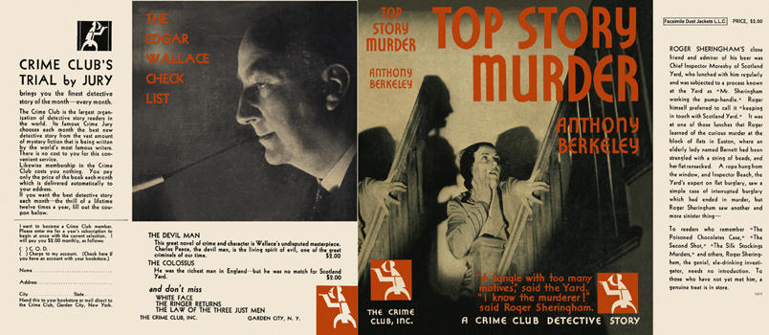

Top Story Murder
Berkeley, Anthony
Doubleday The Crime Club (USA) (1931) first printing.

Суперобложки первых изданий книги

