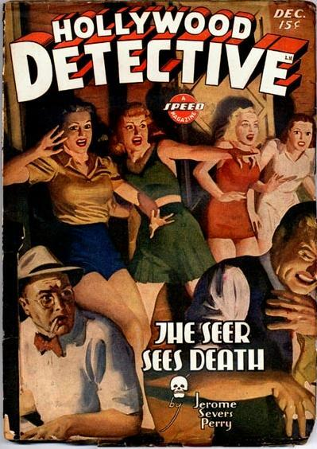

Hollywood Detective [Vol. 3 No. 2, December 1943]

  - 4 · The Seer Sees Death [John J. “Little Jack” Horner] · Jerome Severs Perry · nv
  - 28 · The Lake of the Left-Hand Moon [Dan Turner] · Robert Leslie Bellem · na
  - 64 · The Case of the Homicide Dive [Dan Turner] · Robert Leslie Bellem · cs; illustrated by Adolphe Barreaux
  - 72 · Prune Picking Patriot [Honest John Carmody] · E. Hoffmann Price · ss
  - 84 · Slice of Murder · Ellery Watson Calder · ss
  - 97 · New Racket Warning · [uncredited] · ms
  - 98 · Movie River Flows on Cue · [uncredited] · ar
  - 104 · Criminals Who Ran a City · [uncredited] · ar

Обложка журнала, в котором была впервые напечатана повесть

