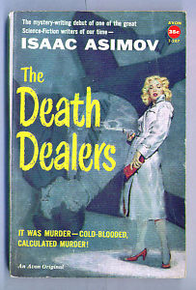

Isaac Asimov
The Death Dealers
Avon (USA), 1958

