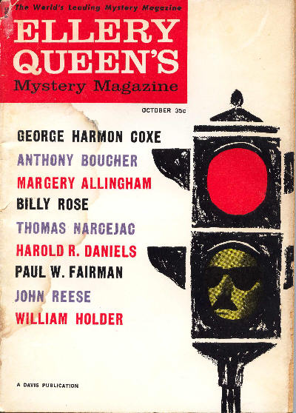

Ellery Queen’s Mystery Magazine [v36 #4, Whole No. 203, October 1960]

  - 5 · The Master Stroke · Harold R. Daniels · ss
  - 12 · A Neat and Tidy Job · George Harmon Coxe · ss
  - 26 · The Restless Ones · Leslie Waller · ss Collier’s February 5 1954
  - 38 · Maigret’s Next-to-Last Case [Insp. Jules Maigret] · Thomas Narcejac; translated by Lawrence G. Blochman · ss
translated from the French (“L’Avant-Dernière Enquête du Commissaire Maigret”, Confidences dans Ma Nuit, Editions Athene, 1946).
  - 55 · The Honeymoon Murders · Maurice Baudin, Jr. · ss Esquire April 1945, as “The End of Indian Summer”
  - 62 · Ladies First · Margaret C. Austin · ss
  - 68 · The Case of the Lovable Taxidermist [Lieutenant] · Nicholas DiMinno · ss
  - 87 · Best Mysteries of the Month · Anthony Boucher · br
  - 88 · The Man Next Door · William Holder · ss The Elks Magazine 1955, as “A Face Next Door”
  - 94 · The Symbolic Logic of Murder · John Reese · ss
  - 107 · Beyond All Doubt · Billy Rose · vi Collier’s July 19 1947
  - 110 · Wally the Optimistic Op [Wally Watts] · Paul W. Fairman · ss
  - 118 · Family Affair [Albert Campion] · Margery Allingham · ss
  - 129 · The Ultimate Clue · Anthony Boucher · vi

Обложка журнала, в котором был впервые напечатан рассказ

