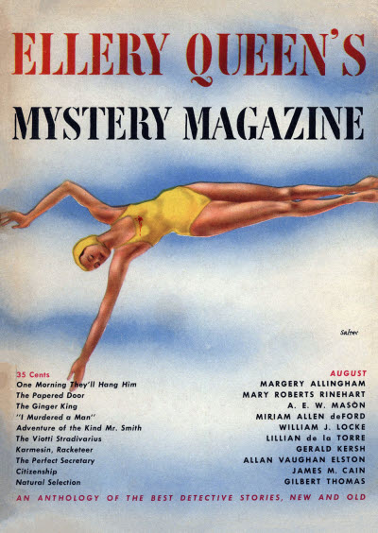

Ellery Queen’s Mystery Magazine [v16, #81, August 1950]

  - 3 · One Morning They’ll Hang Him [Albert Campion] · Margery Allingham · ss
  - 17 · “I Murdered a Man” · Miriam Allen deFord · nv
  - 37 · The Perfect Secretary · Allan Vaughan Elston · ss 1947
copyright 1947, United Newspapers Magazine Corporation, probably from This Week.
  - 46 · The Viotti Stradivarius [Dr. Sam: Johnson] · Lillian de la Torre · ss
  - 65 · Citizenship · James M. Cain · pl The American Mercury December 1929
  - 74 · Natural Selection · Gilbert Thomas · ss
  - 81 · Naboth’s Vineyard [Uncle Abner] · Melville Davisson Post · ss Metropolitan Magazine December 1912
  - 93 · Adventure of the Kind Mr. Smith [Aristide Pujol] · William J. Locke · ss The Strand Magazine June 1911
  - 108 · The Papered Door · Mary Roberts Rinehart · ss Collier’s March 21 1914
  - 123 · The Adventures of Karmesin, Karmesin: Racketeer [Karmesin] · Gerald Kersh · ss Courier Summer 1939, as “Karmesin and the Unbeliever”
  - 129 · The Ginger King [Insp. Gabriel Hanaud] · A. E. W. Mason · ss The Strand Magazine August 1940

Обложка журнала, в котором был впервые напечатан рассказ

